Exercises

* Change the width and height of an image to 200 pixels both.
* Create an *OutlinedButton* widget that displays the text *Cancel*.
* Create a function called *cancel* that prints *Cancel button is clicked*, and pass it to the *onPressed* parameter of the *OutlinedButton* widget created in the previous step.
* Change the background color of the *OutlinedButton* widget to *Colors.purple*.
* Add a padding of 10 pixels to the *OutlinedButton* widget at the **top and bottom** only.
* Add a padding of 60 pixels to the *OutlinedButton* widget using *SizedBox* widget.

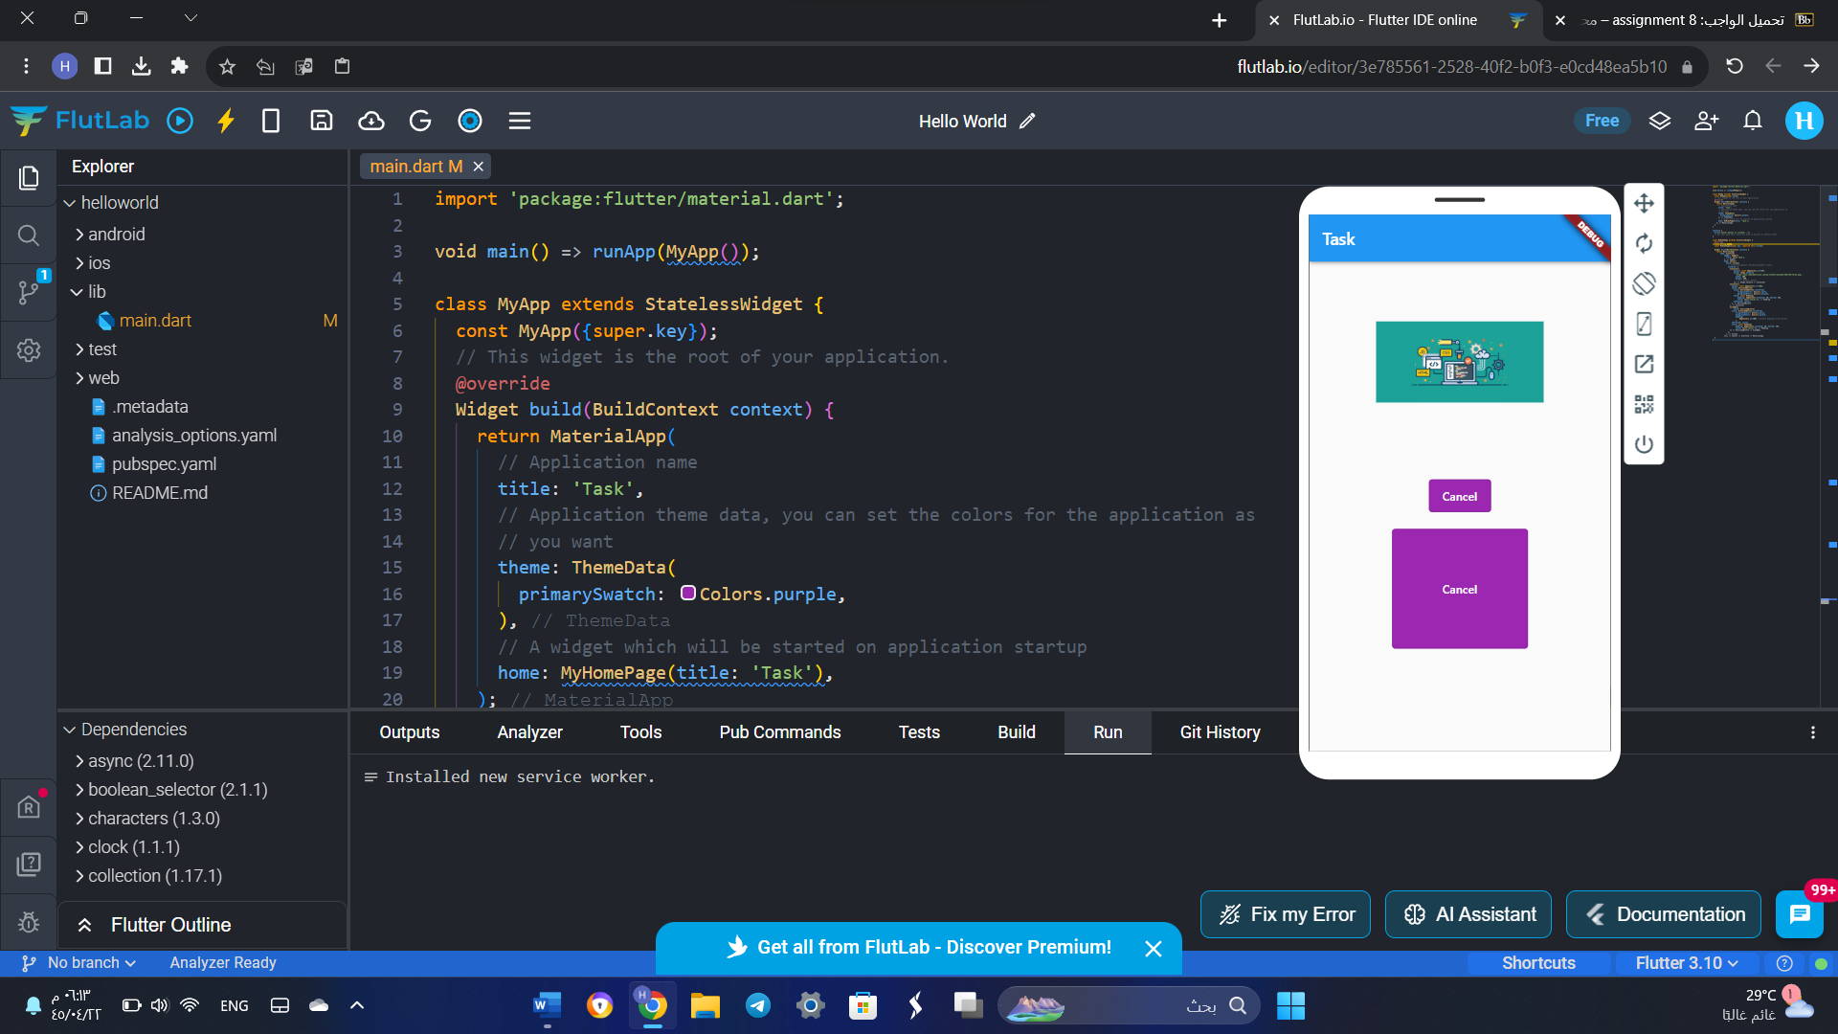

import 'package:flutter/material.dart';

void main() => runApp(MyApp());

class MyApp extends StatelessWidget {

  const MyApp({super.key});

  // This widget is the root of your application.

  @override

  Widget build(BuildContext context) {

    return MaterialApp(

      // Application name

      title: 'Task',

      // Application theme data, you can set the colors for the application as

      // you want

      theme: ThemeData(

        primarySwatch: Colors.purple,

      ),

      // A widget which will be started on application startup

      home: MyHomePage(title: 'Task'),

    );

  }

}

cancel() {

  print('Cancel button is clicked...');

  // Put your code here, which you want to execute on onPress event.

}

class MyHomePage extends StatelessWidget {

  @override

  final String title;

  const MyHomePage({super.key, required this.title});

  Widget build(BuildContext context) {

    return MaterialApp(

        home: Scaffold(

            appBar: AppBar(

              title: Text('Task'),

            ),

            body: Center(

              child: Column(

                // mainAxisAlignment: MainAxisAlignment.center,

                children: [

                  Container(

                      margin: const EdgeInsets.all(20),

                      child: Image.network(

                        'https://www.codeimmersives.com/wp-content/uploads/2021/04/term1.png',

                        width: 200,

                        height: 200,

                        // fit: BoxFit.contain,

                      )),

                  Container(

                    margin: const EdgeInsets.all(20),

                    child: OutlinedButton(

                      style: OutlinedButton.styleFrom(

                          foregroundColor: Colors.white,

                          backgroundColor: Colors.purple),

                      child: const Padding(

                          padding: EdgeInsets.only(top: 10, bottom: 10),

                          child: Text('Cancel')),

                      onPressed: cancel,

                    ),

                  ),

                  SizedBox(

                      child: OutlinedButton(

                    style: ElevatedButton.styleFrom(

                        foregroundColor: Colors.white,

                        backgroundColor: Colors.purple,

                        padding:

                            EdgeInsets.all(60) //content padding inside button

                        ),

                    onPressed: cancel,

                    child: const Padding(

                        padding: EdgeInsets.only(top: 10, bottom: 10),

                        child: Text('Cancel')),

                  ))

                ],

              ),

            )));

  }

}